Transform **a binary tree** holding character strings **into** a **doubly-linked list** such a way that you can reconstruct the tree from the created list.

Hint: - mark the leafs of the tree (which are NULL nodes) in the list with a special character (for example “*”)

Input: any tree created like in the lab session

ex: *1 2 3 * * 4 * * 5 6 * * 7 * \**

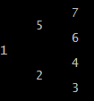

Output:

* The list formed from the tree (in our case it would be: *1 2 3 ** 4 * * 5 6 * * 7 * \**)
* And the tree printed out again.

The main function should look like:

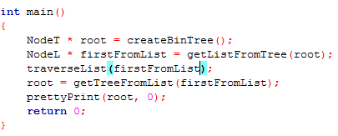

Due date(s):

30411 – 30.03.2015 (before 12:00 if you want review and before 23:59 if you want a grade)  
30414 – 31.03.2015 (before 12:00 if you want review and before 23:59 if you want a grade)